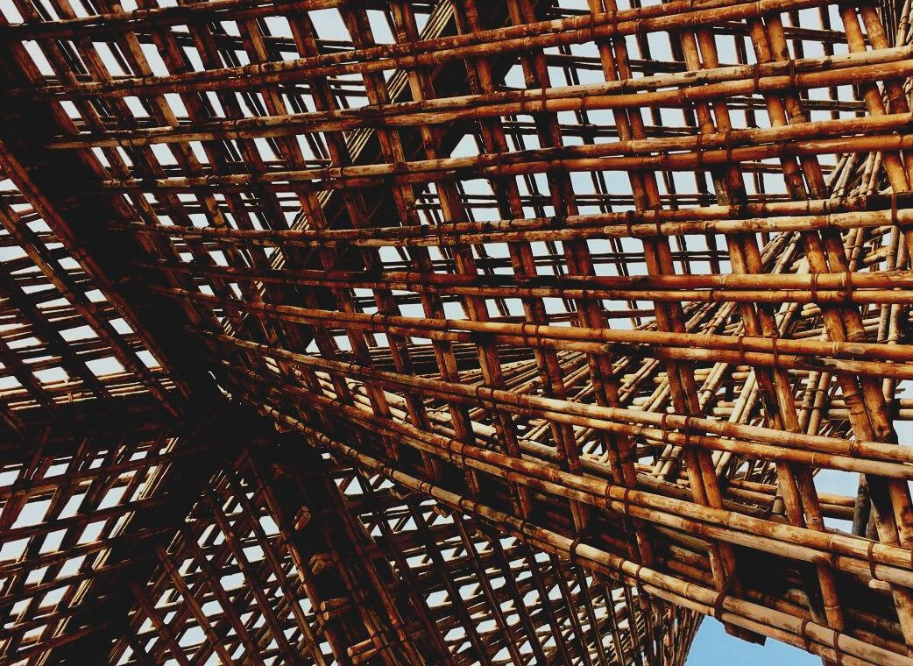

UPWOOD
Up-skilling construction workers in wood construction methods for energy-efficient buildings

UPWOOD
Up-skilling construction workers in wood construction methods for energy-efficient buildings

methods for energy-efficient buildings

UPWOOD
Up-skilling construction workers in wood construction methods for energy-efficient buildings

methods for energy-efficient buildings

UPWOOD
Up-skilling construction workers in wood construction methods for energy-efficient buildings

methods for energy-efficient buildings

UPWOOD
Up-skilling construction workers in wood construction methods for energy-efficient buildings

truction methods for energy-efficient buildings

UPWOOD
Up-skilling construction workers in wood construction methods for energy-efficient buildings

methods for energy-efficient buildings

UPWOOD
Up-skilling construction workers in wood construction methods for energy-efficient buildings

methods for energy-efficient buildings

UPWOOD
Up-skilling construction workers in wood construction methods for energy-efficient buildings

methods for energy-efficient buildings

UPWOOD
Up-skilling construction workers in wood construction methods for energy-efficient buildings

TRAINING & ASSESSMENT
MATERIAL

Learning Unit 4
- Lessons 3 & 4: Energy-efficiency value of wood as a building material and wooden constructions.

TRAINING & ASSESSMENT
MATERIAL

Learning Unit 4
- Lesson 1: Energy-efficiency value of wood as a building material and wooden constructions.

TRAINING & ASSESSMENT
MATERIAL

Learning Unit 4
- Lesson 1: Energy-efficiency value of wood as a building material and wooden constructions.

TRAINING & ASSESSMENT
MATERIAL

Learning Unit 4
- Lesson 1: Energy-efficiency value of wood as a building material and wooden constructions.

TRAINING & ASSESSMENT
MATERIAL

Learning Unit 4
- Lesson 1: Energy-efficiency value of wood as a building material and wooden constructions.

TRAINING & ASSESSMENT
MATERIAL

Learning Unit 4
- Lesson 1: Energy-efficiency value of wood as a building material and wooden constructions.

TRAINING & ASSESSMENT
MATERIAL

Learning Unit 4
- Lesson 1: Energy-efficiency value of wood as a building material and wooden constructions.

TRAINING & ASSESSMENT
MATERIAL

Learning Unit 4
- Lesson 1: Energy-efficiency value of wood as a building material and wooden constructions.

CONTENT
1. CONTENT 1
2. INTRODUCTORY PARAGRAPH 2
3. PLUMBING AND DRYWALL CONSTRUCTION 3
3.1. Plumbing 3
3.2. Dry construction and seal system 8
4. INSIGHTS TO HEATING, VENTILATION, AIR CONDITIONING, LIGHTING, INFORMATION AND COMMUNICATIONS TECHNOLOGIES SYSTEMS AND ITS APPLICATIONS IN MODERN BUILDINGS 12
4.1. Electrical notions 12
4.2. Ventilation 14
4.3. Air conditioning 15
4.4. Telecomunications 18
5. BIBLIOGRAPHY: 20

INTRODUCTORY PARAGRAPH
During all the construction phases it is mandatory for all the workers to have a proper knowledge of partitioning, plumbing and general installation.
In this unit the focus will be divided in two major categories: partition and plumbing, general installation; maintaining all the information general and keeping in mind that for each country there will be a possibility of some small adjusting at the local regulations.
Regarding partitions, the dry construction system will be analysed regarding its advantages and the different requirements to be used. In addition, the way of sealing will be mentioned too, for giving the user a general knowledge of this important part of the construction phase.
The second part of this block consist in giving some knowledge about the plumbing system, its materials, how it works and general data of hydraulic installations keeping in mind timber construction.
The second major category will embody all the notions about the principal installations in a building. There will be sections about electrical installations, how it works and the different parts that composes it.
Major focus will be made about ventilation, how the openings of the building should be carried out and the different type of solutions available for keeping the comfort of the building, especially of timber, such as air conditioning. Finally, a proper attention will be made on communication technology systems, considering its development in timber, its options and way of installation.

PLUMBING AND DRYWALL CONSTRUCTION

Plumbing
In order to provide an adequate supply of water, it is important to be aware of the properties of the pipes that are installed in each building, assuring a minimum set of conditions for the provided water, such as potability, endurance against corrosion, temperature fluctuation resistance, and enough flow and pressure.
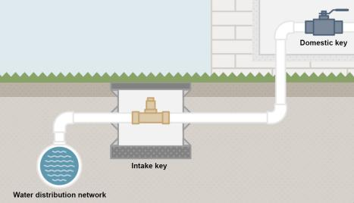
    - Cold water supply
In most cases, the water should be provided from an urban distribution network, where the building piping network is connected, providing water to the whole building.
Fig. 1. Water distribution network.
Source 1. Valvulas Arco

From the point the canalisation gets inside the building, a general key should be disposed, as well as a non-return valve, to guarantee the quality of the distribution network’s water. Then, after a filter which guarantees the potability of water, it flows through every water meter, counting the consumption of each dwelling. Form this point, water supply runs through the whole building through common zones, supplying water to every dwelling or local.

Fig. 2. Water supply diagram from distribution network to each duelling
Source 2.

    - Hot water
Every dwelling must be provided with domestic hot water, with a private heating system installed inside the dwelling, or through a common heating system for the whole building, or even with a public supply of hot water.
Since the temperature of hot water can get to hight values, it is important to have some previous considerations, given the issues that this temperature could carry. At first, it is important to verify that the pipes material can stand these maximum temperatures, assuring its durability and reliability. Also in order to avoid this hight temperatures to interfere with the cold water supply it is important to provide enough separation between them.
    - Renewable energy contribution to water heating
Aside of the conventional heating systems for domestic hot water, there is a very sustainable system that can assist to the heating processes proving every building with a minimum amount of low energy-cost hot water, which is the installation of thermal solar panels. This panels make use of sun’s high irradiation temperature to heat domestic hot water supplies. Nevertheless, It is not as simple as flowing this water through the panels. This process requires a heat exchange from the heating panels closed circuit to the domestic circuit, as can be seen in
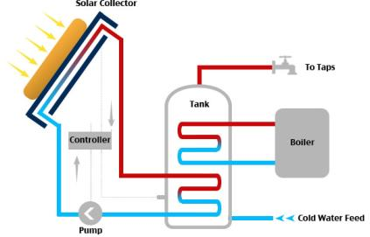
Fig. 3. Symplified Solar thermal system.
Source 3. EEWeb

    - Sanitation
Aside of the clean water supply, it is really important to project an adequate sanitation network, in order to evacuate all the dirty water from inside the dwellings, as well as the rainwater from the roof and terraces.
For an adequate disposition of the sanitation installation, it is important to follow these considerations:
- Hydraulic locks should be placed in all pipes in order to avoid the air content to flow into the dwelling.
- Shape of drain piping system should be as wide and simple as possible, easing the flow of different substances.
- The network should be accessible for its maintenance and repair, if needed.
- Ventilation systems must be taken into account, for the adequate functioning of Hydraulic locks and gasses evacuation.
- It should be ensured the proper disposition of all the downspouts, assuring a flow of substances with no deviations or changes of shape until they get to the collectors.
It is important to assure the adequate ventilation design of all the drainpipes, since they guarantee the healthiness of dwellings, avoiding all gasses and substances to interfere in the building, due to adverse pressure variations.
Also, one very relevant topic to have in consideration is the noise that these evacuations can emit. In order to avoid noises from these circulations, the adequate shape of the pipe lines should be designed, and an adequate insulation can be provided when needed.

    - Materials
The used materials for the pipes can be metallic, made from cement components, or plastic, being several different specific variations of each material to be used, where the most common ones are made metallic or plastic.
In case of metallic pipes, these are the most relevant types of section:
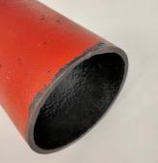
- Cast Iron pipes. These can be combined with other materials, such as cement, protective paintings, or PVC. These pipes are commonly used for supply lines.
- Lead pipes. This type of pipe can be toxic, since it may drop some particles. For this reason, this kind of pipes are no longer allowed, and must be replaced.

- Steel pipes. This type of pipe is used for closed circuits only and cannot be used for sanitary purposes.
- Stainless steel pipes. These sort of pipes are quite commonly used, but they can be expensive due to the quality of the material. They can be used in several topics since their properties are really good.
- Galvanized steel. These pipes have good properties against corrosion, and can be used for several purposes, including domestic hot and cold water.

- Cupper pipes. These are the most commonly used for cold and hot domestic water, since they have very good performance against corrosion.

In case of plastic pipes, these are the most relevant types of section:
- PVC-U. This type of plastic pipe is cannot be used for domestic purposes, and it is commonly used for closed circuits, specially for pool’s circuits.

- PVC-C. These pipes have good properties, but they are not really common. They can be used for domestic use, among others.

- Polyethylene Pipes. There are three different densities for this material. The softer one is used mostly for irrigating.
- PEX Polyethylene. These type of sections are the most commonly used in domestic-use water, since is the easiest to install, and its price is not high at all.
- PER Polyethylene. This plastic material has good properties and can be used in several water supply purposes. One of the most common use is for radiant floors.

- Polypropylene. This plastic material has good properties, but it is not so commonly used since its assembly is not easy.
- Polybutylene. This material has also good properties and can be used for domestic uses, but one of the issues it can present is its dilatation.

- Multilayer composite pipes. This material has really good properties, since it combines some materials in order to provide some of the properties of each. It combines some plastic with metallic materials.

Dry construction and seal system
Nowadays, the different types of industrial facade closures, such as light systems consisting of metal and wood panels, prefabricated plaster panels and the different curtain wall constructions, constitute a technological alternative and economically competitive alternative compared to traditional closures, built from various sections of ceramic brickwork or concrete .
This type of industrialized construction system to guarantee their stability and strength needs a support structure that has its anchoring and fixing elements.
The advantages of this type of construction in comparison to traditional methods are:
a) Low weight, either because the materials that make up the panels and elements of the auxiliary structure are light, either because they can achieve the necessary stiffness with little thickness and, therefore, with low mass.
b) Construction speed. The panels are manufactured in a workshop, while other operations are carried out “in situ”. When they arrive at work, they are assembled with dry systems, which reduces the time for setting up in work.
c) High quality control and homogeneity of the product as it is manufactured in industrial installations, allowing more strict manufacturing controls than possible with “in situ” execution processes.
d) Large plastic possibilities, with a wide range of finishing materials, shapes, dimensions, of superficial textures and of colours.
As façade construction systems, light closures with metallic and wooden panels must meet behavioural requirements indicated in the different Technical Building Codes in charge in each region. The system has to be safe structurally, must have enough mechanical strength to withstand the direct actions of its own weight, wind and impacts and indirect actions caused by differential seating, earthquake or imposed deformation without suffering damage that make it lose its characteristics or prevent it from performing its function.
The condition of air and water tightness although is not so relevant for facades, must be taken in account as in roofs. The facade closures must be projected preventing any possible humidity that can be produced by the action of the external water acting on the building.
The water and air tightness of the industrialized facades will be achieved if the outer surface of the panels and their joints do not allow the passage of outside air or rainwater into the interior of the closure they delimit. For this, a specific treatment of the joints between panels will be necessary.
In the design of facades, the control of losses and heat gains must be considered, so as to attenuate the effects of extreme temperatures and reduce the energy consumption necessary to reach the conditions of comfort in the interior of the buildings.
The acoustic requirements for light closures are to limit the risk of discomfort or diseases within the buildings, under normal conditions of use to the dwelling users.
In general, acoustic insulation requirements are established by rates that must be exceeded by the construction systems and can be checked on site by conducting a standard acoustic insulation test in the finished building; the value of the result of this test is directly comparable with the value of the index to be surpassed.
From the point of view of fire safety, the design of the facades should consider the conditions and design criteria tending to evaluate the reaction and the fire resistance of its components. According to the European Classification of Reaction to fire the parameters taken in account are degree of combustibility, smoke emission and the parameter indicative of dropping of droplets or inflamed particle.
Ventilation is another requirement necessary to enable the optimal condition of usage of the building, regarding the renovation of indoor air.
Light closures finally have to be able to last in time. Considering an adequate use and maintenance, industrialized closures must respond satisfactorily to all behavioural requirements already commented, at least during the period of useful life established for the building to which they serve as external closure. The maintenance of the properties and the characteristics of the material used represent the major problem, it is recommended that a series of periodic and economic works of conservation and cleaning, that must be done without appreciable diminution of the dwelling use.

Elements that conform the light closures
In this type of closures every element has an importance and solves a certain problem. The three main parts are the panels, the auxiliar structure and the joints.
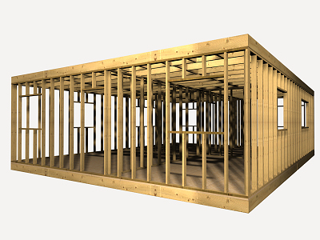
The panels constitute the element that gives the external appearance of the closure depending on the texture, the colour and texture chosen.
The auxiliar structure is the one transmitting the efforts that they receive, mainly their own weight and the action of the wind, to the load bearing structure of the building.

It can be formed only by resistant elements arranged vertically (struts), only by sturdy elements arranged horizontally (crossbeams), or by a framework of sturdy elements arranged vertically and horizontally, which is called an auxiliary structure in the form of a flat grid.
The joint between panels is also necessary to ensure compliance with many of the requirements and behavioural conditions required by the panels themselves. In them, many of the technical and constructive problems of this closure system are concentrated, which have largely been solved thanks to the advances of the chemical industry in the field of new materials for their closure and sealing panels.
The wood panels
Depending on the material used in its visible layers, it is possible to distinguish between wood panels and phenolic panels.
The high-density wood panels in which only their two visible layers are natural wood, 0.8 mm. of thickness, obtained by development cut.
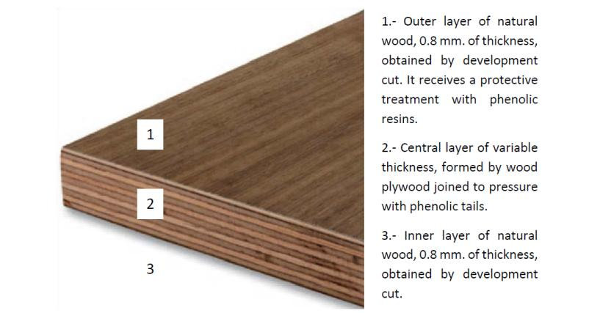
Fig. 4. High density wood panel section
Source 4. UPV.

Seal system.
In order to provide the best quality to the interior spaces, it is really important to have in consideration the sealing of the enclosures, as well as the interior partition walls.

- For the enclosures, it is really important to ensure the sealing and tightness against outer threats, such as rain, dust, or specially air temperature exchanges.
For this reason, it is mandatory to dispose a sealing system between panels, and between the dry panels and other constructive elements in order to ensure the tightness of interior spaces.
Some of the most important spots to have in consideration when implementing the sealing tapes are as follows:

- Foundation to Sheathing. As can be seen in figure 5, the dry elements must not be in contact with the foundation element. For that reason an elastic band is placed right below the secondary structure system, to provide the necessary seal. Also, the sheathing element is also separated from the foundation, filling the joint with sealing material.
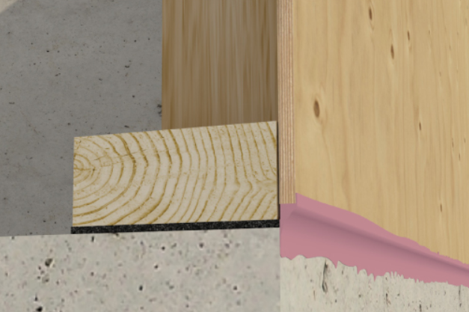
Fig. 5. Sheating encounter with building foundation.
Source 5. Hammerandhand.com
- Between panels at sheathing. It is also important to provide the necessary seal between the panels for the adequate thermal conditions for the interior of the building, as can be seen at figure 6.
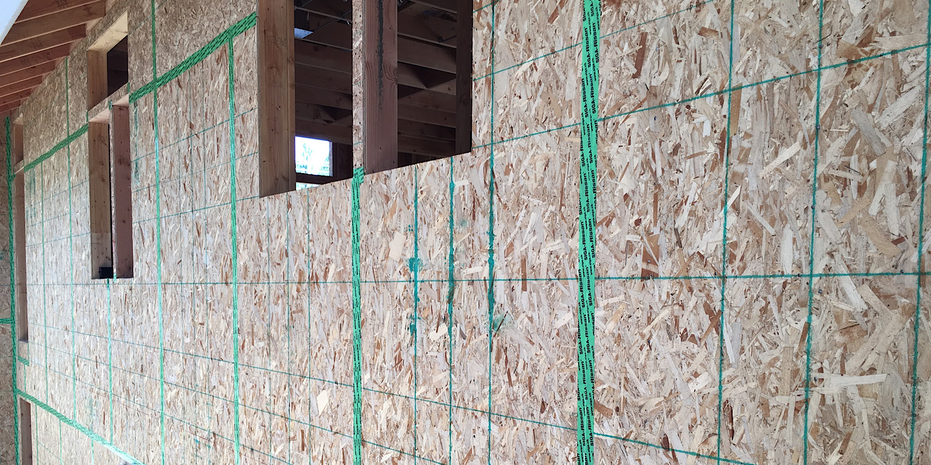
Fig. 6. Adhesive sealing elements between dry construction pannels.
Source 6. Greenbuilderbedia.com
- Encounter between exterior wall sheathing to interior ceiling transition. In this case, in the same way as with the foundation encounter, it is very important to provide the adequate sealing between elements, as can be seen in figure 7.
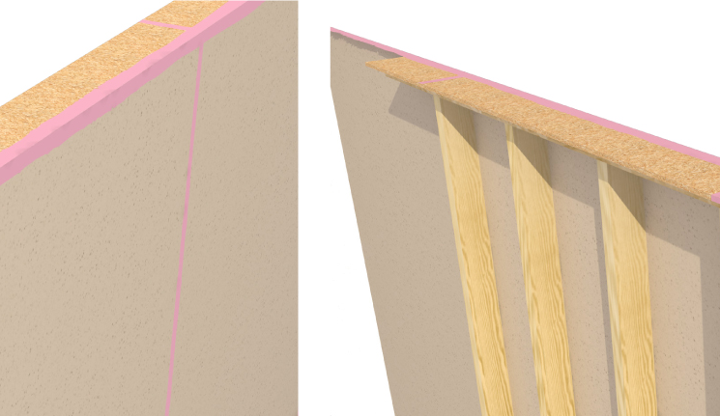
Fig. 7. Encounter between exterior wall and ceiling.
Source 7. Hammerandhand.com
- The last encounter to have in consideration Is between the elements that compose the ceiling/roof, in order to provide the required tightness to the con joint. An example can be seen in figure 8.
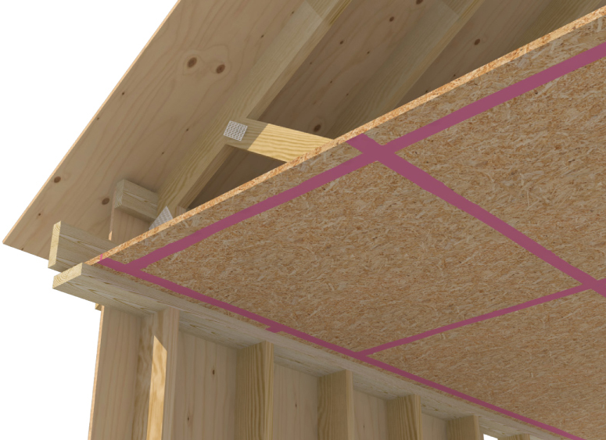
Fig. 8. Encounter between horitzontal elements.
Source 8. Hammerandhand.com

- For the partition walls. In this case, it is always really important to have in consideration the sealing between interior spaces, in order to guarantee the thermal and acoustic insulation to every space.
To maintain the tightness of interior spaces like those, an elastic band bust be place right below the structure that carries the panels, as well as in the boundaries of the wall (encounters with other walls or ceiling). A detail of this type of elastic band can be seen in figure 9.
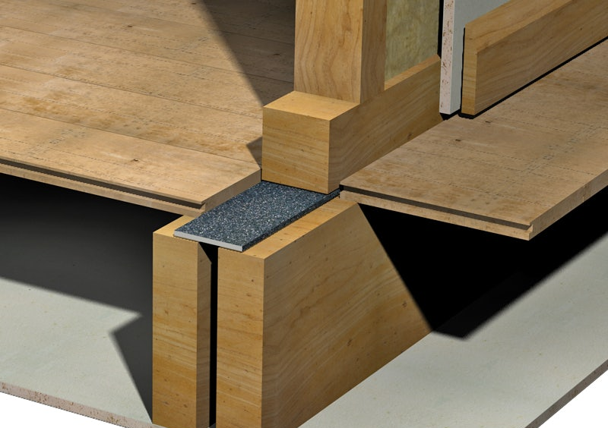
Fig. 9. Displacement of insulation tape surrounding the partition wall.
Source 9. Isomass

INSIGHTS TO HEATING, VENTILATION, AIR CONDITIONING, LIGHTING, INFORMATION AND COMMUNICATIONS TECHNOLOGIES SYSTEMS AND ITS APPLICATIONS IN MODERN BUILDINGS

Electrical notions
The origin of electrical power is in generating stations, where we can find the alternators. The tension energy is elevated in step-up transformers to been transported through the transmission lines. When the energy is near the consumption places, the energy tension is reduced reaching the primary distribution network. When the point of use is reached the tension must be adjusted to the domestic one in the step-down transformer.
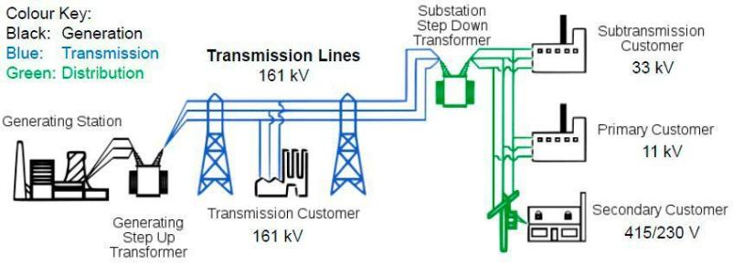
Fig. 10. Electricity generation and distribution scheme.
Source 10.Solo Nunoo via ResearchGate
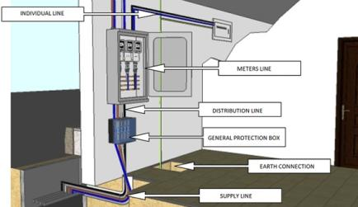
Parts of the electric installation
Fig. 11. Link installations scheme.
Supply line
Link installations:
1.General protection box
2.General power supply
--- general shunting breaker---
3. Meters
4. Individual line
5. Box for power control circuit breaker
Source 11. UPV.
6. General devices of control and protection

Interior installation:
7. Interior installation
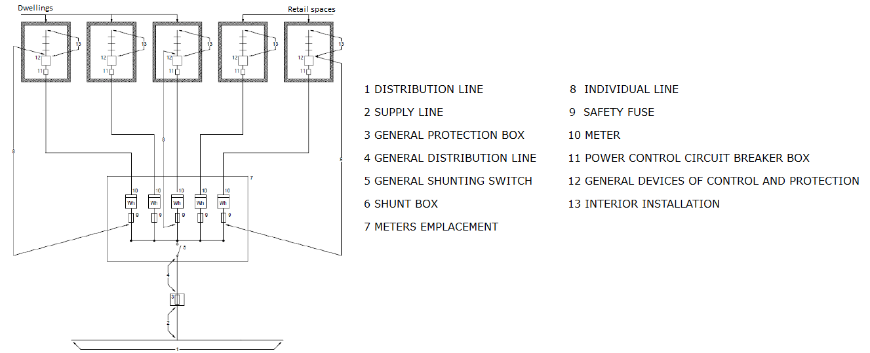
Fig. 12. Dwelling electric installation scheme
Source 12. UPV
Interior installations
This kind of installations transport the electricity from the General devices of control and protection to the consumption points.
There are two different kinds: general services (lightning of stairs, fire alarms, elevators, garages…) and dwellings.
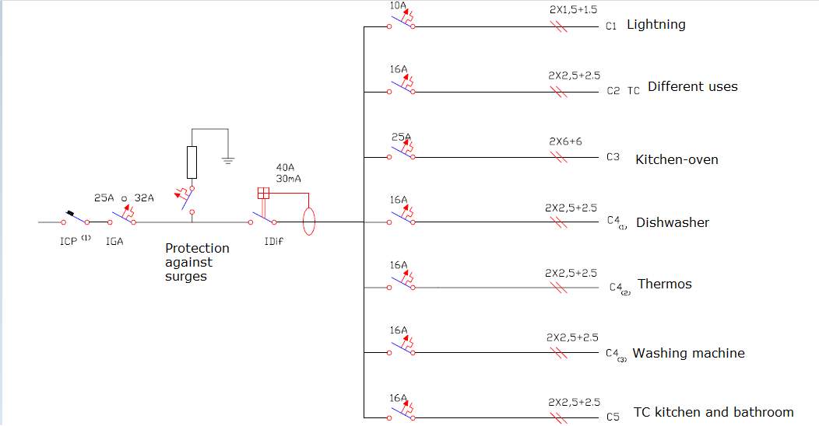
Fig. 13. Interior installation scheme
Source 13. UPV

Ventilation
Ventilation is a necessary mechanism for the renovation of indoor air, but also has positive effects on the thermal conditions of the premises, such as night cooling in summer, or hygrothermic, such as the replacement of saturated indoor air by another exterior with lower moisture content to avoid condensations.
The facade cladding should serve to allow the ventilation of the interior space with the outside air through windows, doors and even other specific mechanisms integrated in it, such as ventilation grilles.
In this sense, CTE-DB-HS (Health), in its section HS3 (Indoor air quality), establishes that housing must have a general ventilation system that can be hybrid or mechanical with l the following characteristics:

- a) Intake openings16 are provided with aerators or fixed attachments of the carpentry, such as microventilation devices; however, when exterior carpenters are class 1 of air permeability according to UNE EN 12207: 2000, the opening joints may be considered as inlet openings.

- b) The aerators17 must be arranged at a distance from the ground greater than 1,80 m.

- c) Kitchens, dining rooms, bedrooms and living rooms must have a complementary natural ventilation system. A practicable external window or an external door must be provided.

- d) The total practicable area of the windows and exterior doors of each room must be at least one-twentieth of the useful surface thereof.

Air conditioning
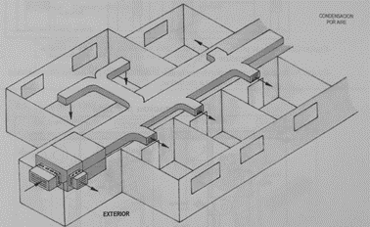
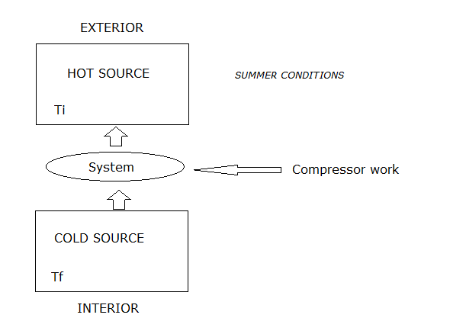
Air conditioning must be able to maintain the levels of comfort required by the user. The conditions are going to be different in summer or winter, in the interior of the room considered, there is going to be an energetic interchange between its and the environment, in winter the balance of the interchange will be negative due to the loss of heating higher than the gain and in summer will be positive. In summer to keep the comfort inside designated places its needed cool and dehumidify air proportioned by the air system. To been able to expel the excess of heating from the interior to the exterior of the room, the system of ‘cool production’ must been able to transfer heat from the cool source to the heat source. To produce the constant flow of cool fluid there are two possible methods: compression and absorption. The most used are the compression mechanisms based in the inverted Carnot cycle.
Source 14. UPV
Fig. 14. Air conditioning distribution scheme
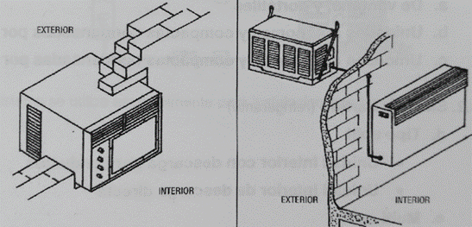
Types of installation
Source 15. UPV
Fig. 15. Compact unit and portable unit
- Purpose
-Industrial processes
-Comfort installation
- Season
-Only winter
-Only summer
-All year
- Refrigeration fluid
- Air
-Water
-Refrigerants
- Installation
  - Unit
-For windows and portables
- Compacts and autonomous units condensate by air
- Compacts and autonomous units condensate by water
  - Parted system
-Split type (discharge by conducts or direct)
-multi-split
  - Centralized systems
-Mixed (induction or fan coil)
- All air (steady flow, variable volume, two conducts)

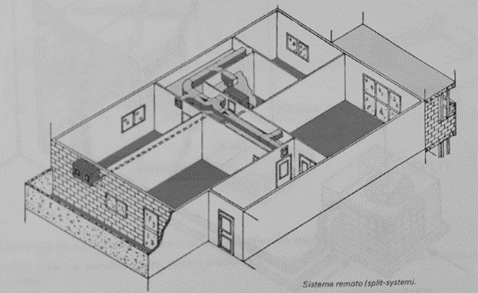

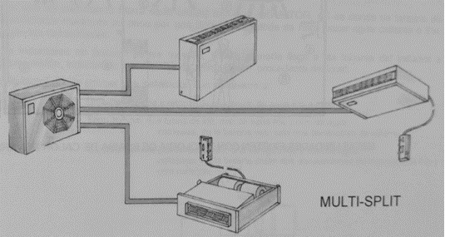
Source 11. UPV
Source 12. UPV
Fig. 12. Multy-Split system
Fig. 11. Single Split system.

Telecomunications

This type of installations capture, adapt and distribute to the houses and establishments all sort of telecommunication devices.
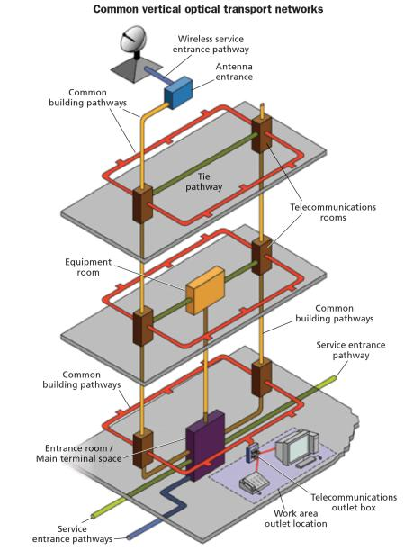
Following the proper legislation, every building has the permission to have installations regarding telecommunications. The entire equipment must be sufficient for all the users of the building, containing all services such television, telephone, and telecommunication by line. The design of the building should take in consideration this kind of amenities and help the adaptation to future installations. Every building permit includes a project that takes in consideration
A common vertical optical transport network extends from the basement to the roof and appears in every telecom room. The physical cabling and active electronics for the vertical transport need to be segregated and identified separate from tenant networks. Source: web 3
telecomunications
infrastructures.
The begining of the construction works are not allowed without the proper validation of a telecomunication installation project.
During the early stages of construction works, small changes in the project are allowed, but in case of important changes a new project should be presented to the autorities and finally aproved.
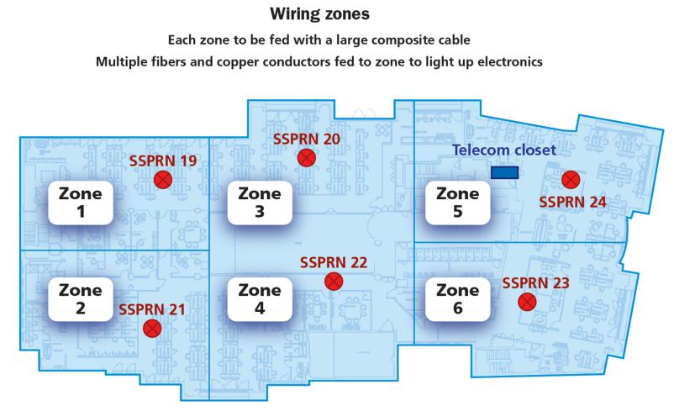
The installations chose in the ultimate projects are arranged in a vertical optical transport network that extends from the basement to the roof and appears in every telecom closet. In case of a smart building(preferable option nowadays) the logical heart of the transport network would be in the meet-me room, the place where the conjunctions of the providers meet. From a service-protection perspective, the physical cabling and active electronics for the vertical transport need to be segregated and identified separate from tenant networks.
With this floor divided into 6 wiring zones, each zone can be fed with a large composite cable, which contains multiple fibers and copper conductors. The composite cables provide data and power to the electronics in each zone. Source: web 3

BIBLIOGRAPHY:
-web1:
https://www.boe.es/eli/es/rd/2011/03/11/346/con/20110401
-web2:
http://www.ictingenieros.com/ICT-Infraestructura-comun-de-telecomunicaciones.html
-web3:
https://www.cablinginstall.com/design-install/cabling-installation/article/14036591/corning-cabling-futureready-commercial-office-buildings

