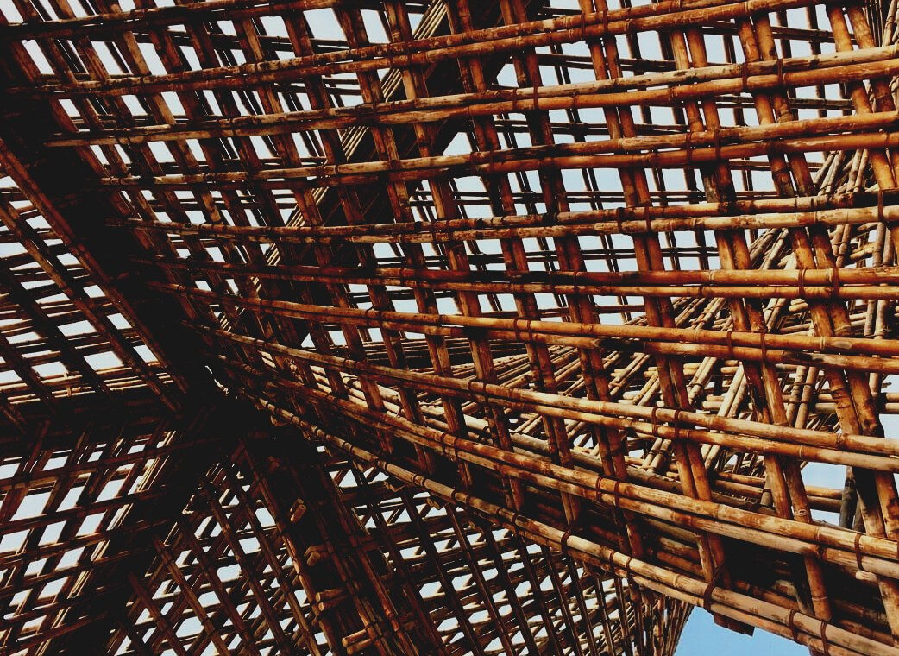

**TRAINING MATERIAL**

Learning Unit 2

WOODEN TRUSSES

UPWOOD-PUU

*Up-skilling construction workers in wood construction methods for energy-efficient buildings*

UPWOOD-PUU

*Rakennustyöläisten ammattitaito energiatehokkaiden rakennusten puurakentamisenmenetelmissä*

Table of contents

1. Introduction 2

1.1. I-beams 2

1.2. Roof trusses 2

2. Trusses 2

2.1 Fire classification 5

2.2 Humidity of the operating conditions 5

2.3 Positioning of brackets 6

2.4 Deflection support 6

2.5 Stiffening of the water roof 6

2.6 Protrusions and eaves 7

2.7 Support, fastening and anchoring 7

2.8 Manufacturing 7

2.9 Installation 8

2.10 Transportation 8

2.11 Storing 8

3. List of references 10

# Introduction

The so-called main raw material for composite products is sawn timber. Such products include NR gratings, NR dowel beams, and I-beams. Usually, such products are manufactured according to a separate plan, but I-beams, for example, are also available by the meter.

## I-beams

The I-beam is designed for load-bearing structures. The I-beam is light beam support combined by gluing from pairs of wood and fiberboard or plywood. Its applications are the mezzanine, upper and lower floor beams of buildings as well as external wall frames. I-beams achieve the same load-bearing capacity with less material than glulam or sawn timber.

## Roof trusses

Load-bearing structures made of sawn timber also include roof trusses, the structure of which is based on nail plate joints and are referred to as NR trusses (brush trusses, scissor trusses, and console trusses), NR trusses, and NR dowel beams.

In the event of a fire, a timber, LVL, or glulam beam may be used as the load-bearing lower bracket, but the dowel beam may not be used for this purpose in the event of a fire. The narrow lower truss of the NR trusses becomes narrow and high in cross-section, so it requires a relatively dense torsional support.

# Trusses

With the help of prefabricated nail plate trusses, the shape of the water cover is advantageously achieved, as well as the finished primary frame for both the water roof and the ceiling of the top floor. However, gratings cannot be easily elementated, which increases the workload on site. In truss structures, the stiffening plate in the upper floor can be placed either at the level of the lower or upper part. It is recommended to place it at the level of the upper part, as this will also act as buckling support for the upper part.

The nail plate is a connector that allows efficient use of wood, and the lattice has a rigid structure and small deflections. With the help of 3D design, nail plate supports can be made light, dimensionally accurate, versatile, and individual, which speeds up installation and also thermal insulation work.

There are different types of roof trusses and they can be divided into different basic types, such as ridge truss, scissor truss, desk truss, beam truss, perimeter truss, sloping rod attic, straight rod attic, T-scissor truss, attic truss, and truss beam.

Below are a few different roof trusses.

|  |  |  |  |
| --- | --- | --- | --- |
| Brush truss |  |  |  |
| Scissor roof truss |  |  |  |
| Desk truss |  |  |  |
| Truss |  | | |
| Attic bracket |  |  |  |
| Wooden frames |  |  |  |

The bars of the plane trusses are divided into two groups in the dimensioning: edge bars (upper girder, lower girder) and inner or web girders (all vertical (vertical) and diagonal girders (diagonal) between the upper and lower girder). The points of attachment and attachment of the rods are called nodes or joints.

Unless a more general model is used, the grids are analyzed as rods placed on the system lines and connected at nodes, as shown in the figure below. The system lines of all bars must remain within the cross-section of the bar, and on the chord, they must coincide with the centerline of the bar. A more general structural model of lattice bars can be made with shell elements, but the model can become very uneconomical.



Image 1 Puurakenteet © Rakennustieto Oy

Plane grid: (a) centerline, (b) aperture or node spacing, (c) inner bar, (d) support, (e) chord, (j) imaginary beam element, (g) knot.

## Fire classification

A truss is not a fire-rated structure if it has unprotected nail plate joints, so it can only be used in fire-retardant buildings. In fire-retardant and fire-resistant buildings, the use of trusses is limited to structures that are not essential parts of the load-bearing frame or fire-stiffening parts. The fire safety class requirements for buildings and building components are presented in Part E1 of the Finnish Building Code, Structural Fire Safety.

Nail plate joints or the entire bracket can also be fire-protected. An unprotected nail plate joint has a fire-resistance time of fewer than 10 minutes. Mineral wool-protected joints have been achieved in fire tests of resistance to fire for more than half an hour.

## Humidity of the operating conditions

Gratings connected with a nail plate can be used in moisture classes 1 and 2. In moisture class 3, brackets can be used if the dimensioning of the grid considers the deterioration of the strength of the nail plate joint due to high humidity. For pressure-impregnated wood, only stainless-steel nail plates should be used.

The moisture classes of wooden structures are divided into four categories according to the conditions of use.

Moisture class 1 includes a wooden structure that is in a heated interior or similar humidity conditions, as well as structures in a thermal insulation layer and beams with a tensile side inside the thermal insulation.

Moisture class 2 includes wood structure material that is dry in the open air. The structure must be in a covered space and well protected from getting wet from below and from the sides.

Moisture class 3 includes wood material that is moist and exposed to the weather.

Moisture class 4 includes wood material that is directly affected by water.

## Positioning of brackets

The width of the plate-like thermal insulators should be considered when designing the girder distribution, as they are installed between the girders. The recommended support pitches are 900 mm or 1200 mm. If inflatable thermal insulation is used, the gratings can also be placed with other support divisions. Differences in deflection of adjacent and similarly shaped but differently supported supports can be significant and are reflected in the ridge and eaves lines of the building. The brackets are then designed so that their deflections are equal. It is not recommended to place the brackets on the sloping part of the outer wall of the bay window.

If no load-bearing end walls are designed for the building, the distance of the outermost girder from its end eaves to the outer edge shall not exceed ½ cross-section.

## Deflection support

For buckling-supported bars, a horizontal board is attached to the center of the bars, which is tied to the upper or lower bar level with diagonal boards. The buckling support is designed and dimensioned for the horizontal force of each rod.

To prevent buckling of the upper ribs, a split of 60 cm is sufficient, but if necessary, the strength can be ensured by nailing additional ribs. If a riser is used under the rafter, the buckling force and the required support distance for the chord must be considered when attaching the riser.

## Stiffening of the water roof

A separate water roof stiffening plan must always be drawn up for the building, in which wind loads and additional horizontal loads caused by the buckling support of the upper trusses of the trusses are routed to the stiffening wall lines. Possible ways of stiffening the water roof are nail plate-structured or on-site stiffening trusses and girders, plate stiffening on chords or ribs, vertical supports together with lower bracket plate stiffening.

Bitumen board roof tongue boarding usually does not have a sufficient plate stiffening effect. The fastening of the form plate covers can be dimensioned so that the cover acts as a stiffening plate.

## Protrusions and eaves

The problem with a cantilever or long open cornice is deflection, which can be checked approximately by dimensioning the cornice as a cantilever beam rigidly attached to the support. Care is also required in the design of girders located at bay windows that the girder has a sufficient support height.

If the building has a cantilevered and end-supported bracket next to each other, a deflection difference is created on the eaves line, which can be reduced by making the upper girder from multi-layer wood, supporting the girders in the outer beam, or placing the beam inside the girders.

The end eaves are made by extending the ribs over the end of the building. If the load-bearing capacity of the ribs is not sufficient, a smaller rib division or larger ribs are planned from the outermost support gap. The Swedes are supported on the load-bearing end wall or end bracket of the building.

## Support, fastening and anchoring

The trusses are usually supported on a sidewall or flattened overhead timber, but the building uses harder support surfaces than wood, such as multi-layer wood, steel, or concrete and the support width is not sufficient, the support areas must be reinforced at the factory.

For truss fastenings, one corner bracket, which is nailed to one side of the chord, which is a factory-made galvanized steel plate and a pre-perforated corner bracket, is usually sufficient. The nails used are recommended by the bracket manufacturer.

## Manufacturing

The gratings are manufactured in specialized production facilities under quality assurance approved by the Ministry of the Environment. The grids shall be stamped with an official stamp indicating the manufacturer, the drawing number, and the week of manufacture. The truss is manufactured using strength-graded and dimensioned lumber, as well as nail plates, which have received an approved statement of the strength values of the plate. After strength grading, the sawn timber entering the truss is cut to the planned dimensions and angles and assembled by pressing the nail plates on both sides of the joint.

## Installation

The installation and handling and support instructions are followed when installing the grilles. Support during work is done so that the trusses remain in place with loads during construction. The placement of the trusses always complies with the tolerance requirements and the truss can only be supported at the points marked on the drawings, the centers of which must be located in the support areas shown in the drawing and the support width of the support must be as planned. The upper trusses of the truss are supported with ribs, the nailing instructions of which are given in the installation instructions for the truss delivery.

## Transportation

The grids are designed for use in an upright position, in which position they should also be transported. If the trusses are transported horizontally, they must be fastened together to prevent harmful lateral bending of the trusses.

## Storing

During storage, the gratings are protected from rain, snow, and ice in a vertical or horizontal position on a horizontal surface, thus preventing the formation of permanent lateral deflections. The trusses are stored on such high sleepers that their lower girder and eaves do not come into contact with the ground and a sufficient ventilation distance is left under the protection from the weather, thus preventing the formation of mold and keeping the truss moisture at an acceptable level.

The upright nail plate supports are tied together and supported vertically from the support points. If the supports are stored horizontally on top of each other, the base and intermediate supports must be on the same vertical line.

# List of references

RT 21-11289. Puutavara, jatkojalosteet. Helsinki: Rakennustieto Oy

RT-21-11289 SIT 24-610147 Infra 064-710190. Puutavara, jatkojalosteet. Helsinki: Rakennustieto Oy

RT 85-10495. Puuristikot ja -kehät. 1993. Helsinki: Rakennustieto Oy

Riikonen, J. 2019. NR-suunnittelun vaikutus naulalevy- ja puumäärään. Savonia.

Tolppanen, T., Karjalainen, M., Lahtela, T. & Viljakainen, M. *Rakenteet, suunnittelu ja rakentaminen*. 2013. Puuinfo. Tampere: Juvenes Print – Suomen Yliopistopaino Oy

Suortti-Suominen, T. & Valtion teknillinen tutkimuskeskus. *Puurakenteet*. 1996. Tampere: Rakennustieto Oy